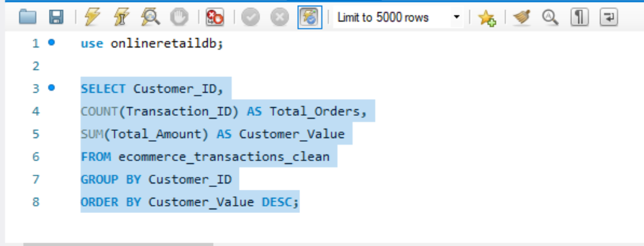

Customer Lifetime Value (CLTV) is a metric that estimates how much revenue a customer generates for the business over their relationship with the company.



